Deep Learning-Based System for 3D Single-Tooth Orientation Prediction & Automatic Surface Coloring
Internship Organization: National Dental Centre Singapore (NDCS)

Project Background and Clinical Significance

1.1 Background and Motivation
In traditional dental Computer-Aided Design (CAD), the identification and labeling of tooth orientations are performed manually. This process is not only time-consuming but also highly susceptible to human error, which can compromise the precision of subsequent dental prosthetics. The National Dental Centre Singapore (NDCS) is currently enhancing its digital dentistry infrastructure by developing "SMART RPD," a web-based module for 2D and 3D denture design. This transition creates a critical need for an automated system capable of establishing consistent coordinate references for tooth models within a digital environment.

1.2 Research Objectives
The primary objective of this project is to develop and train a robust AI-based model capable of automatically determining the orientation of 3D single-tooth meshes. Specifically, the system is designed to accurately identify the four core anatomical surfaces: the Mesial, Distal, Buccal, and Lingual faces. To achieve this classification across diverse tooth geometries, the workflow involves extracting critical geometric and morphological features directly from the raw 3D scans.
The ultimate goal is to process any given tooth geometry and label its anatomical surfaces consistently, thereby establishing a highly reliable automated framework for dental analysis.

1.3 Clinical Significance and Applications
Automating tooth orientation prediction offers substantial improvements to clinical workflows by providing a fundamental alignment and coordinate reference for downstream tasks, specifically the "SMART RPD" 2D/3D denture design module. Integrating this AI-driven spatial awareness significantly improves the overall automation and accuracy of digital dental design workflows. Furthermore, the project incorporates an integrated visualization module that highlights each predicted orientation surface in a distinct color. This automated coloring logic enables the real-time, interactive rendering of the anatomical surfaces, allowing clinicians to effortlessly conduct visual verifications before proceeding with complex prosthodontic planning.

Data Preparation

Dataset Acquisition and Automated Segmentation
The foundation of this project relies on the construction of the 3D Single Tooth Orientation Dataset (3D-STOD), derived from the broader Teeth3DS+ (3DTeethLand) dental scanning dataset.
To transition from full-arch clinical scans to individual tooth models, a customized automated extraction pipeline was developed using Python. Utilizing FDI tooth numbering indices (specifically ranging from 11-27 and 31-47), individual teeth were successfully isolated from the complete dental arches through a vertex-wise masking approach.
Furthermore, a K-Dimensional Tree (KDTree) spatial mapping algorithm was employed to associate spatial landmark coordinates with their corresponding tooth IDs based on their proximity to labeled vertices. Ultimately, this automated segmentation workflow successfully yielded 3180 pristine single-tooth samples extracted from 155 original full dental arch meshes.

Data Processing
Following the segmentation phase, extensive data normalization and feature engineering were conducted to optimize the inputs for the Point Transformer network. To eliminate the interference of absolute spatial positioning within the oral cavity and compel the model to learn pure geometric morphological features, each extracted single-tooth mesh and its corresponding landmark coordinates were zero-centered by translating the geometric center to the coordinate origin. Consequently, each processed sample was structured into three core components: a normalized 3D geometric mesh (.off format), a JSON file containing the zero-centered landmark coordinates, and a heavily engineered feature matrix (.npy format). This feature matrix serves as the core ground truth for training, formatted as an array shaped (5, N_faces) representing pre-computed Euclidean distance maps. Specifically, this matrix records the exact Euclidean distances from every mesh face center to five predefined anatomical landmarks: the Mesial, Distal, InnerPoint (Lingual), OuterPoint (Buccal), and the optional FacialPoint.
  - Anti-Leakage Partitioning Strategy
Clinical dental datasets inherently contain natural variances, such as severe wear or dental crowding, which resulted in incomplete annotations for 36.3% of the samples (1155 partially annotated teeth versus 2025 fully annotated teeth). To maximize the network's exposure to diverse dental morphologies while strictly handling missing labels, a "Max-Value Padding" strategy was implemented, filling the missing distance map channels with a maximum penalty value of 20mm. During network training, this padded value triggers a loss masking mechanism, forcing the model to learn solely from available surfaces and ignore missing channels via zeroed gradients. Finally, to prevent data leakage and ensure robust clinical evaluation, the dataset was rigorously partitioned at the patient and arch level. Utilizing an 85% training (131 arches) and 15% testing (24 arches) split strategy, the pipeline guarantees that multiple teeth belonging to the same patient never cross over between the training and testing sets.

Training and Coloring Process

Network Architecture Design
The core of the orientation prediction framework is built upon a Point Transformer v3 (PTv3) backbone, heavily customized for 3D coordinate regression tasks.
Rather than utilizing standard 3-dimensional inputs, the LandmarkPointTransformer is specifically engineered to ingest a 6D point cloud representation that seamlessly integrates spatial XYZ coordinates with corresponding surface normal vectors. The architecture sequentially processes these inputs through TransitionDown layers for spatial downsampling and Multi-Head Self-Attention (MHSA) blocks to capture highly localized geometric features. Crucially, to enhance the network's anatomical awareness, an FDI tooth identification embedding is introduced as an explicit prior. The global point cloud features (384 dimensions) are concatenated with these FDI embeddings (64 dimensions) before passing through a multi-layer perceptron (MLP) regression head, which directly predicts the 3D spatial coordinates for the required landmarks.

Training Mechanism and Strategy Optimization
To accommodate the partially annotated samples within the clinical dataset, a dynamic Loss Masking mechanism was integrated directly into the training loop. During backpropagation, the Smooth L1 Loss function systematically evaluates the ground truth distance maps; gradients associated with missing anatomical landmarks (previously padded with the 20.0 mm penalty value) are multiplied by zero using a binary mask. This forces the network to optimize weights exclusively based on clinically valid surfaces.
Additionally, to prevent the numerical instability and NaN losses frequently observed during the early training stages of Transformer models, the pipeline utilizes PyTorch's Automatic Mixed Precision (AMP) with bfloat16 data types. Training is further stabilized and refined using an AdamW optimizer coupled with a ReduceLROnPlateau learning rate scheduler and gradient clipping.

Automatic Surface Coloring Algorithm
The post-prediction surface rendering logic is fundamentally driven by Voronoi spatial principles. Operating directly on the mesh vertices, the algorithm computes the Euclidean distance from every vertex to each of the AI-predicted landmark coordinates. Using a highly optimized broadcasting mechanism, each vertex is subsequently assigned the designated color (e.g., red for Mesial, blue for Distal) of its nearest anatomical landmark. This color assignment is strictly bounded by a user-defined "Color Spread Radius," ensuring the mapped regions accurately reflect localized anatomical boundaries.

Visual Interactive Systemn
To facilitate real-time clinical verification, a comprehensive full-stack visualization system was developed utilizing the Streamlit framework and Plotly's 3D rendering engine. The interactive User Interface (UI) allows end-users to upload raw 3D single-tooth models and instantly visualize both the predicted 3D coordinate markers and the resulting Voronoi-based surface colorization. The UI features a dedicated control panel equipped with dynamic sliders to adjust the color diffusion radius and functional toggles to isolate specific anatomical surfaces, fulfilling the downstream need for intuitive visual verification before advanced denture design.

Results

4.1 Model Performance and Quantitative Analysis
The quantitative evaluation of the LandmarkPointTransformer demonstrates high spatial fidelity and robust convergence throughout the training process. Utilizing the 6D point cloud input (XYZ + Normals) combined with FDI tooth embeddings, the model was trained for 200 epochs using the AdamW optimizer. As recorded in the terminal training logs, the network exhibited a stable decline in loss, reaching its peak performance at Epoch 173 with a learning rate of $4.7×{10}^{-6}$. At this optimal state, the model achieved a training loss of 1.3624 and a validation loss of 0.7967. The primary metric for success, Mean Euclidean Error (MEE), reached a "New Best" of 1.1636 mm on the held-out validation set. This level of precision indicates that the Point Transformer architecture successfully captured the complex morphological nuances of diverse tooth geometries, maintaining high predictive accuracy across the 3180-sample dataset.
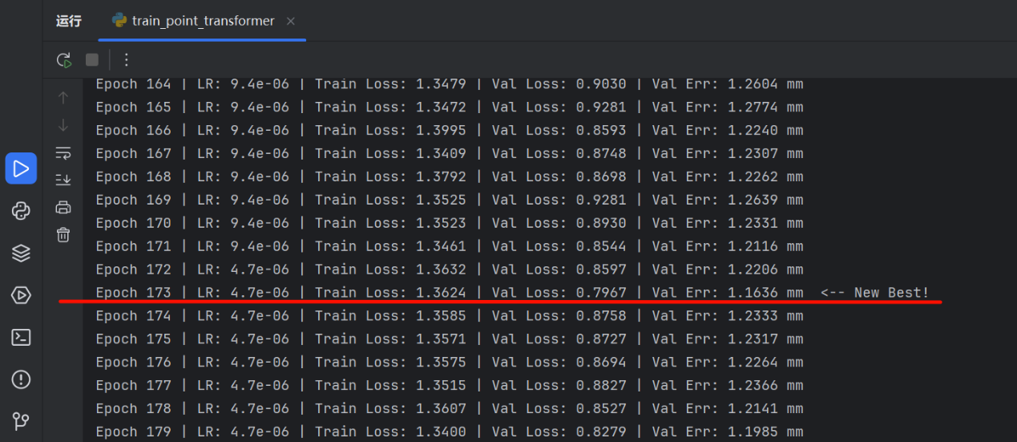

Clinical Validation against Industry Standards
In the domain of digital dentistry and automated landmark detection, the threshold for clinical viability is strictly defined, with an error margin of less than 2.0 mm widely considered acceptable for downstream CAD/CAM applications. The proposed system, achieving an MEE of 1.16 mm, significantly outperforms this established clinical benchmark. By reducing the error to nearly half of the required limit, the model provides a highly reliable foundation for the "SMART RPD" 2D/3D design modules. This level of accuracy ensures that the automated coordinate references are sufficient for precise denture alignment and survey angle management, effectively eliminating the risk of structural misfits that often arise from manual labeling errors.

System Visualization
The final implementation phase involved integrating the trained model into a high-performance, web-based interactive system developed via Streamlit and Plotly. The system is designed to handle raw mesh inputs, such as the sample 0140W3ND_lower_tooth_31.off, which contains 2764 vertices and 5255 faces. Upon processing, the system automatically identifies the FDI Tooth ID (e.g., ID 31) and executes the Voronoi-based coloring algorithm. The user interface provides granular control over the "Color Spread Radius," which was optimized at 6.00 mm for the visualized specimen to ensure clear regional boundaries. As demonstrated in the system screenshot, the AI successfully predicted and rendered the four primary anatomical surfaces: the Mesial (Pink), Distal (Blue), Lingual/Inner (Green), and Buccal/Outer (Yellow) surfaces. The ability to visualize predicted landmarks (represented as diamond markers) alongside the colored mesh allows for instantaneous clinical verification, confirming that the model maintains anatomical consistency even on complex, non-standardized tooth geometries.
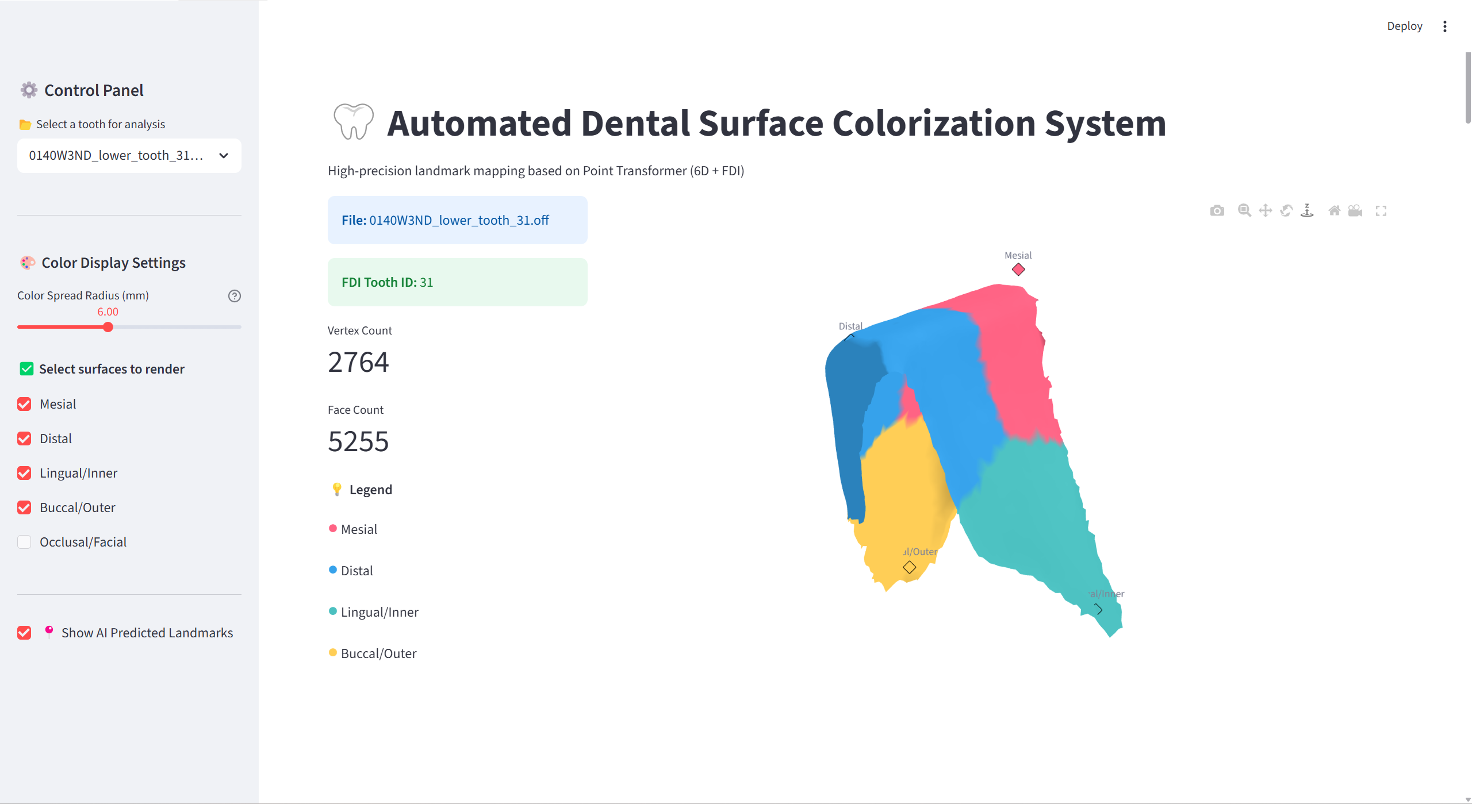

Future Work
The next phase of this research will prioritize enhancing the clinical robustness and generalization capabilities of the current system. A primary objective is to conduct comprehensive cross-dataset verification by evaluating the performance of the trained PTv3 model on external data sources to ensure its reliability across varying clinical environments. To facilitate this independent validation, active communication is currently underway to acquire a specialized 3D dental dataset featuring pre- and post-orthodontic treatments, which will serve as a critical benchmark for testing the model's adaptability to real-world orthodontic cases.
Beyond validation, future efforts will focus on benchmarking alternative geometric deep learning architectures, such as MeshCNN and DGCNN, to identify potential performance optimizations and support the publication of these research findings in academic journals. Furthermore, the framework will be extended to address more complex and challenging clinical scenarios, specifically targeting partial edentulous cases where missing teeth create significant spatial irregularities. By expanding the model's scope to include these scenarios, the system aims to provide a more versatile and comprehensive automation tool for digital dental design and clinical diagnosis.

